**Dr. ZAKIR HUSAIN COLLEGE, ILAYANGUDI**

**DEPARTMENT OF PHYSICS**

**DATA ANALYTICAL REPORT**

**ON**

**A COMPREHENSIVE ANALYSIS OF FINANCIAL PERFORMANCE: INSIGHT FROM A LEADING BANK**

Submitted by,

**TEAM ID: NM2023TMID01811**

1. GOPIKA I (TEAM LEADER) - 0620122006 - asalu6020122006

2. BARKAVI A - 0620122003 - asalu6020122003

3. JARINA BEGAM J - 0620122007 - asalu6020122007

4. VINITHA R - 0620122023 – asalu6020122023

Faculty incharge,

**Mr. P KALEEL AHAMED M.Sc. M.Phil.,**

ASSISTANT PROFESSOR,

DEPARTMENT OF PHYSICS,

Dr. ZAKIR HUSAIN COLLEGE,

ILAYANGUDI.

**1. INTRODUCTION**

**OVERVIEW AND PURPOSE:**

A comprehensive analysis of financial performance is an in-depth examination of a company's financial health and efficiency, including its revenue, expenses, profitability, liquidity, solvency, and other key financial metrics. This analysis provides valuable insights into the strengths and weaknesses of a company's financial position, enabling stakeholders to make informed decisions regarding investment, lending, or operational improvements.

The purpose of such an analysis is to gain a deep understanding of a company's financial performance, identify areas of potential risk and opportunity, and develop strategies to improve its financial health and efficiency. It is particularly important for investors, lenders, analysts, and other stakeholders who need to make critical decisions based on accurate and reliable financial data.

A comprehensive analysis of financial performance can be conducted for any type of organization, including banks. In the case of a leading bank, the analysis would provide insights into its overall financial strength, risk management practices, profitability, liquidity, and other key factors that contribute to its success or failure.

**2. PROBLEM DEFINING & DESIGN THINKING**

**EMPATHY MAP**

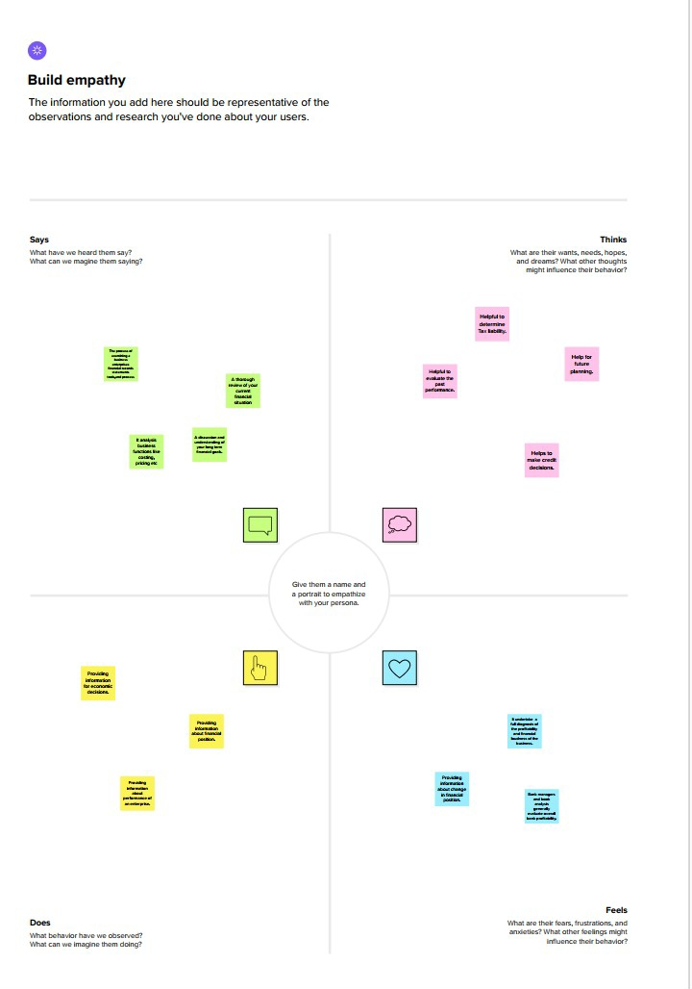

**BRAINSTORMINNG & IDEALISATION**

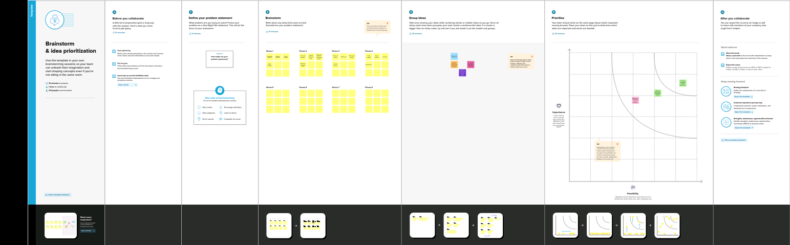

**3. RESULTS**

**DASHBOARDS & STORIES:**

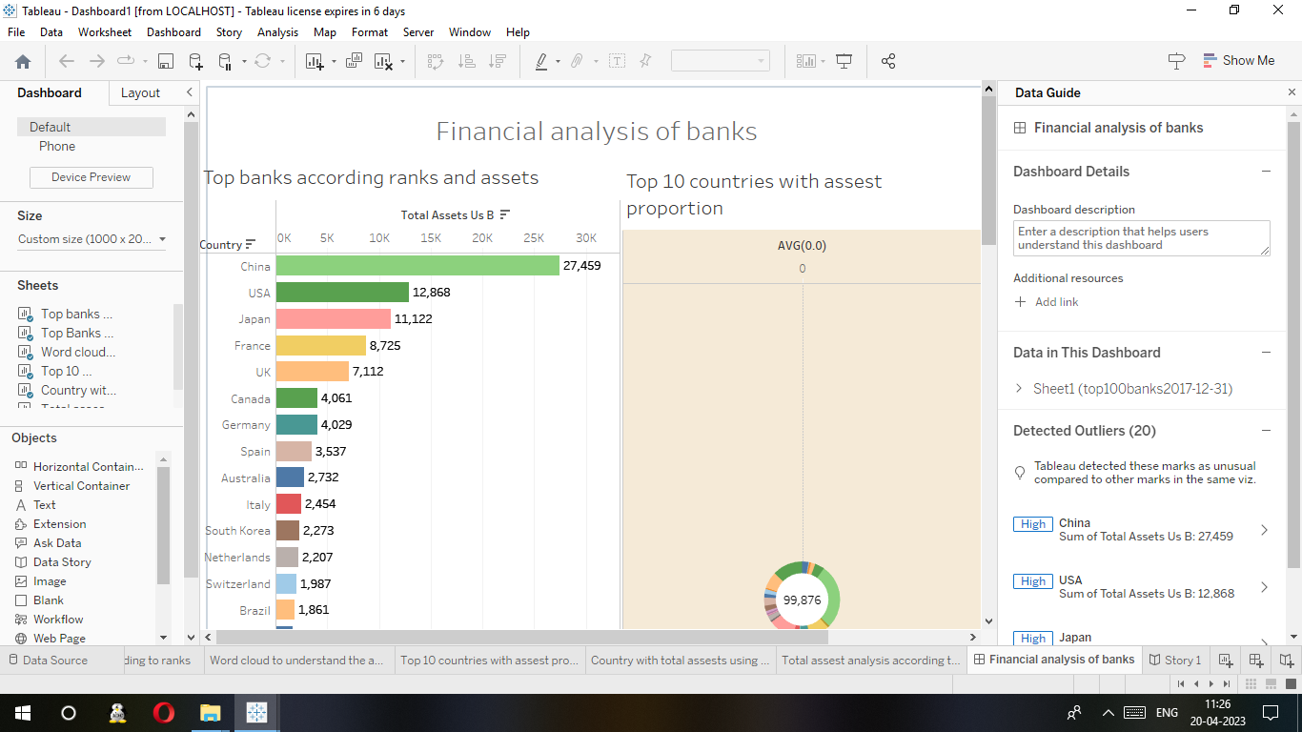

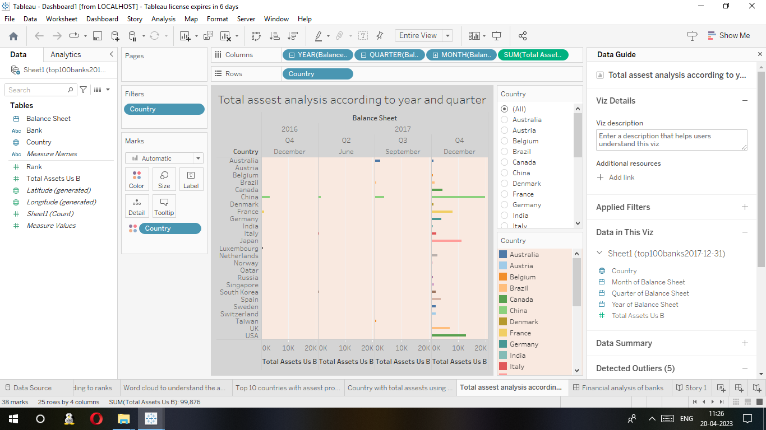

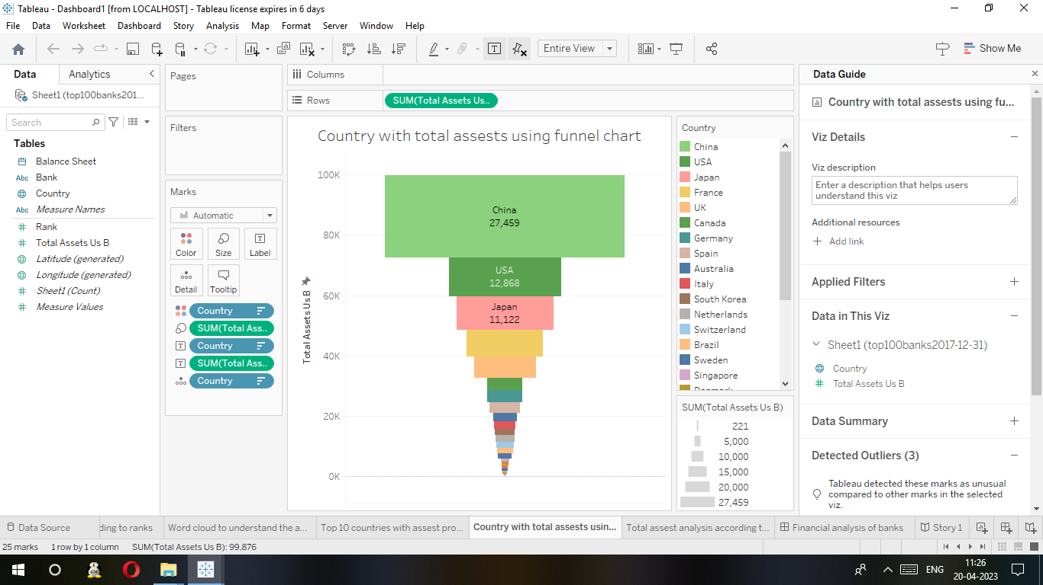

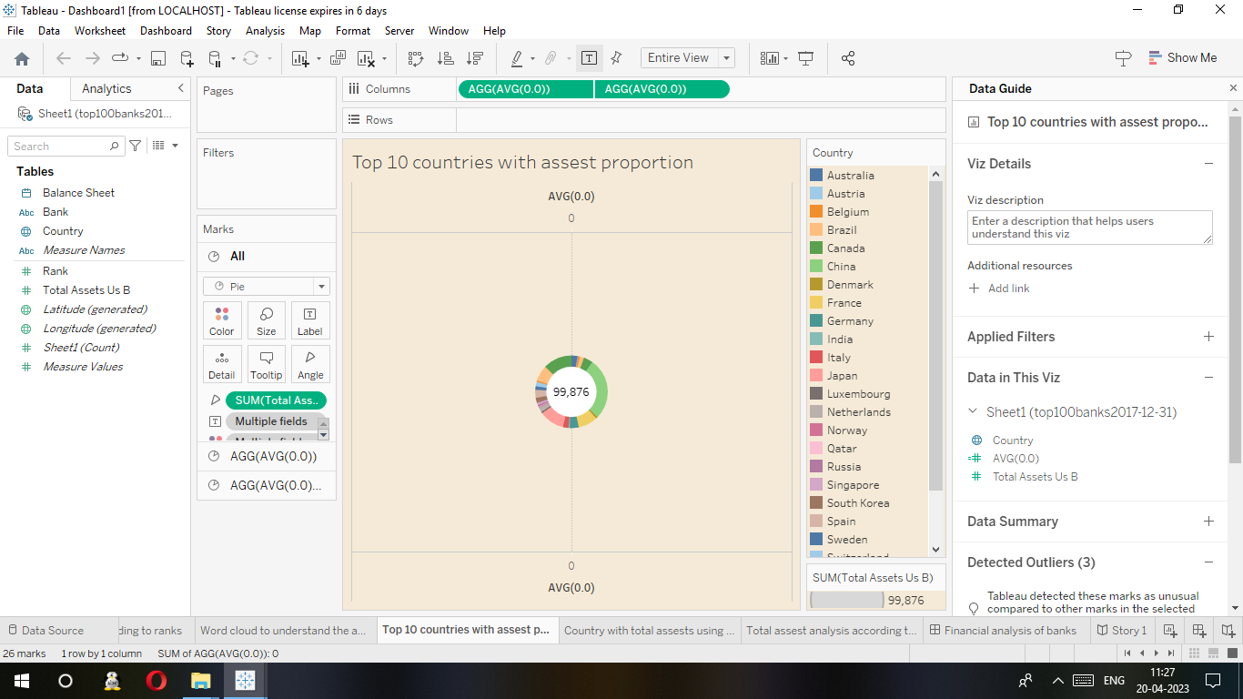



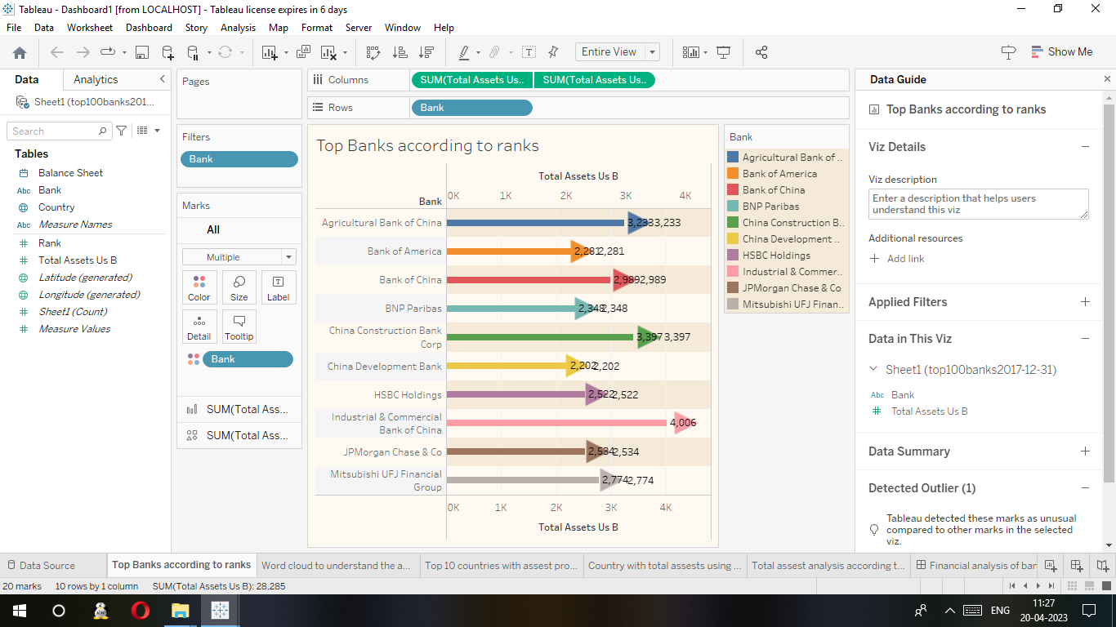

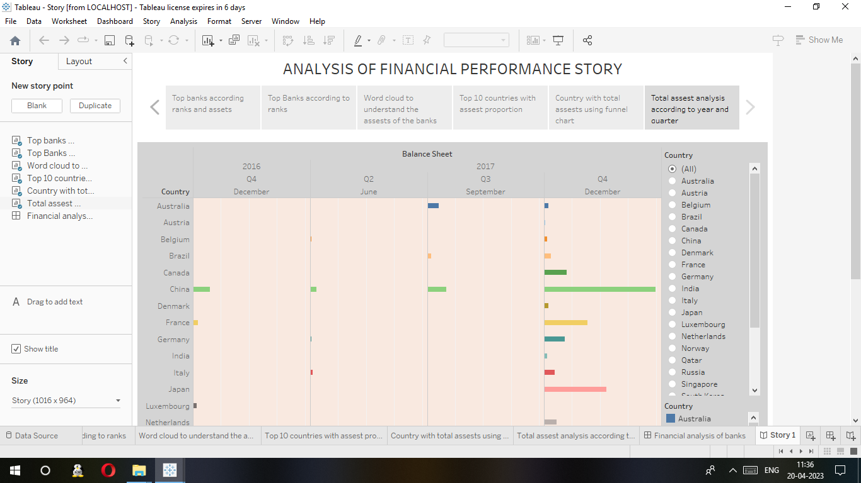

**4. ADVANTAGES AND DISADVANTAGES**

**ADVANTAGES:**

**Better decision-making:** The analysis provides valuable insights into a company's financial position, enabling stakeholders to make informed decisions regarding investment, lending, or operational improvements.

**Improved profitability:** The analysis helps identify areas of potential risk and opportunity, enabling the company to develop strategies to improve its financial health and efficiency.

**Enhanced transparency:** The analysis provides stakeholders with a transparent view of the company's financial performance, promoting accountability and trust.

**Better risk management:** The analysis helps identify potential risks and vulnerabilities, allowing the company to take proactive measures to mitigate them.

**Competitive advantage:** A comprehensive analysis of financial performance can provide the company with a competitive advantage, enabling it to differentiate itself from its peers.

**DISADVANTAGES:**

**Time-consuming**: A comprehensive analysis of financial performance can be time-consuming and require significant resources, which can be a challenge for companies with limited time and budget.

**Limited scope:** The analysis may only focus on quantitative factors, neglecting qualitative factors such as customer satisfaction, employee morale, and market trends, which can impact a company's financial performance.

**Data quality:** The analysis depends on the quality of the data used, and inaccurate or incomplete data can lead to inaccurate conclusions.

**Complex analysis:** The analysis requires specialized skills and knowledge in finance and accounting, which can be a challenge for companies without in-house expertise.

**Overreliance on financial metrics:** Relying too heavily on financial metrics can lead to a narrow focus on short-term financial goals, neglecting the company's long-term vision and sustainability.

**APPLICATION:**

**Investment decisions:** Investors can use the analysis to evaluate a company's financial health and growth potential, helping them make informed investment decisions.

**Lending decisions:** Lenders can use the analysis to assess a borrower's creditworthiness and financial viability, helping them mitigate credit risks.

**Corporate strategy:** Companies can use the analysis to identify areas of potential improvement and develop strategies to enhance their financial performance.

**Merger and acquisition decisions:** Companies can use the analysis to evaluate the financial health and potential synergies of potential merger or acquisition targets.

**Regulatory compliance:** Companies in heavily regulated industries, such as banking, can use the analysis to ensure compliance with regulatory requirements and standards.

**Benchmarking:** Companies can use the analysis to benchmark their financial performance against their peers, identifying areas of competitive advantage or lag.

In the case of a leading bank, a comprehensive analysis of financial performance would be particularly relevant in assessing its overall financial strength, risk management practices, profitability, liquidity, and other key factors that contribute to its success or failure. The insights gained from such an analysis can inform strategic decisions, including capital allocation, product and service offerings, and risk mitigation strategies.

**CONCLUSIONS:**

In conclusion, a comprehensive analysis of financial performance is a critical tool for evaluating a company's financial health and efficiency. It provides valuable insights into the strengths and weaknesses of a company's financial position, enabling stakeholders to make informed decisions regarding investment, lending, or operational improvements.

The advantages of conducting a comprehensive analysis of financial performance include better decision-making, improved profitability, enhanced transparency, better risk management, and a competitive advantage. However, there are also some disadvantages, including the time and resource intensity, the potential for limited scope, the quality of data, the complexity of analysis, and the risk of over-reliance on financial metrics.

The application of a comprehensive analysis of financial performance can be relevant in various settings, including investment decisions, lending decisions, corporate strategy, merger and acquisition decisions, regulatory compliance, and benchmarking. In the case of a leading bank, such an analysis would be particularly relevant in assessing its overall financial strength, risk management practices, profitability, liquidity, and other key factors that contribute to its success or failure.

Overall, a comprehensive analysis of financial performance is a crucial tool for any company looking to improve its financial health and efficiency and make informed decisions to support its long-term growth and success.

**FUTURE WORK**

Incorporating non-financial metrics: Future analysis could incorporate non-financial metrics, such as customer satisfaction, employee engagement, and environmental impact, to provide a more holistic view of a company's performance.

Developing predictive models: Future analysis could develop predictive models that use historical financial data to forecast future financial performance, enabling companies to make proactive decisions and better manage risks.

Evaluating emerging technologies: Future analysis could evaluate the impact of emerging technologies, such as blockchain and artificial intelligence, on financial performance, identifying opportunities for innovation and disruption.

Analyzing the impact of external factors: Future analysis could analyze the impact of external factors, such as macroeconomic trends, regulatory changes, and geopolitical risks, on a company's financial performance.

Conducting comparative analysis: Future analysis could conduct comparative analysis of financial performance across industries, regions, or company types, identifying best practices and areas for improvement.

Incorporating ethical considerations: Future analysis could incorporate ethical considerations, such as corporate social responsibility and sustainable practices, into the evaluation of a company's financial performance.

**WEBPAGE SOURCE CODE:**

